ECE 527 LECTURES
WEEK TWO
SEMICONDUCTOR FIBRICATION PROCESS
Semiconductor devices are of two forms
- (Discrete Units can be diodes, transistors, etc.
- Integrated Circuits uses these discrete units to make one device. Integrated Circuits can be of two basic forms:
Advantages of ICs
- Miniature in size. As fabrication process is used for the integration of active and passive components on to a silicon chip, the IC becomes a lot smaller. When compared to a discrete circuit, it may be at least a thousand times smaller.
- Due to small size, the weight of the IC also reduces, when compared to the discrete circuit.
- To produce hundreds of discrete circuits on a PCB for the same logic takes more time and increase the cost factor. But for the production of hundreds of IC’s the cost of production will be very low and less time consuming.
- The PCB consisting soldered joints will be less reliable. This problem is omitted in ICs because of no soldered joints, with fewer interconnections, and thus highly reliable.
- The small size of IC’s causes lesser power consumption and lesser power loss.
- In a discrete circuitry, if a single transistor becomes faulty, the whole circuit may fail to work. This transistor has to be desoldered and replaced. It is difficult to find out which component has failed. This problem can be omitted in an IC by replacing an entire IC as it is low in cost.
- Increased operating speed because of absence of parasitic capacitance effect.
- As the IC’s are produced in bulk the temperature coefficients and other parameters will be closely matching.
- Improved functional performance as more complex circuits can be fabricated for achieving better characteristics.
- All IC’s are tested for operating ranges in very low and very high temperatures.
- As all the components are fabricated very close to each other in an IC, they are highly suitable for small signal operation, as there won’t be any stray electrical pickup.
- As all the components are fabricated inside the chip, there will not be any external projections.
Disadvantages of ICs
- Some complex ICs maybe costly. If such integrated circuits are used roughly and become faulty, they have to be replaced by a new one. They cannot be repaired as the individual components inside the IC are too small.
- The power rating for most of the IC’s does not exceed more than 10 watts. Thus it is not possible to manufacture high power IC’s.
- Some components like transformers and inductors cannot be integrated into an IC. They have to be connected externally to the semiconductor pins.
- High grade P-N-P assembly is not possible.
- The IC will not work properly if wrongly handled or exposed to excessive heat.
- It is difficult to achieve low temperature coefficient.
- It is difficult to fabricate an IC with low noise.
- It is not possible to fabricate capacitors that exceed a value of 30pF. Thus, high value capacitors are to be connected externally to the IC.
- There is a large value of saturation resistance of transistors.
Types of ICs
Classification is based on
- Size : SSI, MSI, VSLI,USLI
- Application: Digital and linear
- Fabrication Technique monolithic, thin film and thick film, hybrid or multi-chip
- ICs can be classified on the basis of their chip size as given below:
- Small scale integration (SSI)—3 to 30 gates/chip.
- Medium scale integration (MSI)—30 to 300 gates/chip.
- Large scale integration (LSI)—300 to 3,000 gates/chip.
- Very large scale integration (VLSI)—more than 3,000 gates/chip. 100,000 components.
- Ultra large scale integration ULSI more 1 million component on a chip.
- No clear distinction between VLSI and ULSI
- On the basis of applications ICs are of two types namely: Linear Integrated Circuits and Digital Integrated Circuits. Linear IC’s are used in cases when the relationship between the input and output of a circuit is linear. An important application of linear IC is the operational amplifier commonly referred to as op-amp.000000
- When the circuit is either in on-state or off-state and not in between the two, the circuit is called a digital circuit. IC’s used in such circuits are called digital IC’s. They find wid00000000000000000000000000000000000e applications in computers and logic circuits.
- Monolithic-where transistors, diodes, resistors are fabricated and interconnected on the same chip. The word ‘monolithic’ comes from the Greek words ‘mo0nos’ and ‘lithos’ which means ‘single’ and ’stone’. Monolithic ICs are by far the most common type of ICs used in practice, because of mass production, lower cost and higher reliability.
- Hybrid-in these circuits, elements are discrete form and others are connected on the chip with discrete elements externally to those formed on the chip. Hybrids ICs are widely used for high power audio amplifier applications. Have better performance than monolithic ICs; why it gives room for design modification. Hybrid ICs are mostly used for high power audio amplifier applications from 5 Watts to more than 50 Watts. Process is too expensive for mass production
Thick film and thin film
These devices are larger than monolithic ICs but smaller than discrete circuits. These ICs can be used when power requirement is comparatively higher. With a thin-or thick-film IC, the passive components like resistors and capacitors are integrated, but the transistors and diodes are connected as discrete components to form a complete circuit.
The essential difference between the thin- and thick-film ICs is not their relative thickness but the method of deposition of film. Both have similar appearance, properties and general characteristics.
Photolithography process is als0o us0000ed in thick film and thin film
Thin IC Fabrication process0
- This IC is fabricated by depositing0 films of conducting material on the surface of a glass or ceramic base0. The resistors are fabricated by controlling the width and thickness of the films and by using different materials selected for their resistivity. For capacitors, a film of insulating oxide is sandwiched between two conducting films. A spiral form of film is deposited onto the IC to create an inductor.
- Mainly two methods are used for producing thin films. One method, called vacuum evaporation is used in which vaporized material is deposited on a substrate contained in a vacuum. The other method is called cathode sputtering in which atoms from a cathode made of the desired film material are deposited on a substrate located between a cathode and an anode
Thick film process
- They are also commonly called as printed thin film circuits. The desired circuit pattern is obtained on a ceramic substance by using a manufacturing process called silk-screen printing technique
- The cct elements are built up on the substrate by repeated silk screening operations. Silk screening is a printing process in which a thin past material (ink, paint, photoresist) is forced through the unobstructed openings in a fine mesh screen
- The inks used for printing are usually materials that have resistive, conductive, or dielectric properties. They are selected accordingly by the manufacturer.
- The screens are actually made of fine stainless steel wire mesh. The films are fused to the substrate after printing by placing them in hot high temperature furnaces. The fabrication techniques used for thin film passive components are adopted for thick films as well. As with thin-film circuits, active components are added as separate devices
Comparison between Thick film &thin film and monolithic
- When compared to monolithic IC’s, thick and thin film IC’s do have some advantages. They have the advantage of better tolerance, better isolation between components, and greater flexibility in circuit design that further helps in providing high frequency performance. But these are the only factors that must be considered for the application of such IC’s as they are costly in making, and has higher dimensions than monolithic IC’s. They also cannot be used to fabricate active components which further increase the size.
Monolithic IC’s limitations
- Monolithic IC’s have low power rating. They cannot be used for high power applications as they cannot have a power rating of more than 1 watt.
- The isolation between the components inside the IC is poor.
- Components like inductor cannot be fabricated to the IC.
- The passive components that are fabricated inside the IC will be of small value. For higher values they have to be connected externally to the IC pins.
- It is difficult to make a circuit flexible for any kind of variation; a new set of masks is required.
Advantages of Mono IC
- This is the best mode of manufacturing IC’ as they can be made identical, and produces high reliability. The cost factor is also low and can be manufactured in bulk in very less time.
note Hybrid is the opposite of monolithic
Wafer fabrication process
The starting form of silicon, which manufacturers of devices and integrated circuits use, is a circular slice known as a wafer and are normally referred to as the substrate. These wafer diameters vary from 10-20 cms with maximum up to 30 cms.
Silicon is found in abundance in nature as an oxide in sand and quartz. Silicon must be in
- Crystalline form,
- Very pure,
- Free of defects, and
- Uncontaminated
The Czochralski process is a method of crystal growth used to obtain single crystals of semiconductors (e.g., silicon, germanium and gallium arsenide), metals (e.g. palladium, platinum, silver, gold), salts, and synthetic gemstones. The process is named after Polish scientist Jan Czochralski, who discovered the method in 1916 while investigating the crystallization rates of metals.
The distribution coefficient is a function of the material, the impurity, temperature of the solid-liquid interface and the growth rate of the impurity. To grow crystals, one starts with very pure semiconductor grade silicon, which is melted in a quartz-lined graphite crucible. The melt is held at a temperature of 1690K, which is slightly greater than the melting point, (1685K) of silicon.
A precisely controlled quantity of the dopant is added to the melt The ratio of the concentration of impurities in the solid, Co to that in the liquid, Cl, is known as the equilibrium segregation coefficient ko
$$ko={Co}/{Cl}$$
Small seed crystal is suspended in molten material then pulled (1m/hr) and rotated (1/2 rps) to form an ingot
- The wafers are cleaned, rinsed, and dried for use in the fabrication of discrete devices and integrated circuits.
- First step in production of an integrated circuit is growth of a large piece of almost perfectly crystalline semiconducting material called an ingot (boule)
IC fabrication process
- Epitaxial growth. growing a crystal layer of one mineral on the crystal base of another mineral in such a manner that its crystalline orientation is the same as that of the substrate.
- planar technology: This is Combination of basic steps (formation of an SiO₂ layer, its selective removal, introduction of dopant atoms into the wafer surface, and dopant diffusion into silicon) and other fabrication steps that are employed in producing complex devices and circuits. This is the step-by-step and layer-upon-layer method of making circuits on a wafer substrate.
Advantages of planer technology
- A major advantage of the planar process is that each fabrication step is applied to the entire silicon wafer.
- It is possible to not only make and interconnect many devices with high precision to build a complex IC, but also fabricate many IC chips on one wafer at the same time.
Advantages of planer technology
- There is a clear economic advantage to reduce the area of each IC, i.e., to reduce the size of devices and metal interconnects because the result is more chip per wafer and lower cost per chip.
WHY DO WE USE SILICON AND GERNANIUM FOR SEMICONDUCTOR FABRICATION?
- A major advantage of silicon, in addition to its abundant availability in the form of sand, is that it is possible to form a superior stable oxide, SiO₂, which has superb insulating properties.
- Gallium arsenide crystals have a high density of crystal defects, which limit the performance of devices made from it.
- Compound semiconductors, such as GaAs (in contrast to elemental semiconductors such as Si and Ge) are much more difficult to grow in single crystal form.
- Both Si and Ge do not suffer, in the processing steps, from possible decomposition that may occur in compound semiconductors such as Gallium arsenide GaAs.
- Lastly, at the present time, silicon remains the major semiconductor in the industry
STEPS IN FABRICATION OF SEMICONDUCTORS
- The basic processes used to fabricate ICs using silicon planar technology can be categorised as follows:
- Silicon wafer (substrate) preparation
- Epitaxial growth
- Annealing /doping
- Oxidation
- Photolithography/patterning
- Diffusion/deposition
- Ion implantation
- Isolation techniques/craving/scribing
- Metallization/Sputtering
- Testing and packaging
We shall now describe these processes in detail
Wafer production
The following steps are used in the preparation of Si-wafers:
- Crystal growth and doping
- Ingot trimming and grinding
- Ingot slicing
- Wafer polishing and etching
- Wafer cleaning
First step in production of an integrated circuit is growth of a large piece of almost perfectly crystalline semiconducting material called an ingot (boule). Dopants almost always added to the molten material. Ingots are then sawed into wafers approximately 500-1000 μm (0.5 to 1 mm) thick using a diamond tipped saw.
Epitaxial growth
The basic chemical reaction used for the epitaxial growth of pure silicon is the hydrogen reduction of silicon tetrachloride.
SiCl₄ + 2H₂ 1200°C Si + 4HCl (reversible reaction at temp of 1200 degrees
Mostly, epitaxial films with specific impurity concentration are required. This is accomplished by introducing phosphine (PH₃) for the n-type and bi-borane (B₂H₆) for p-type doping into the silicon-tetrachloride hydrogen gas stream.
Photolithography is the transfer of an image using photographic techniques. 1st step is oxidation process.
Photolithography transfers designer generated information (device placement and interconnections) to an actual IC structure using masks which contain the geometrical information.
Annealing /doping
ANNEALING: Implantation is followed by annealing, that is, heating the wafer to a temperature high enough to cause controlled diffusion of the implanted dopant atoms
DOPPING: the process of adding impurity to a silicon wafer in order to change its electrical and chemical properties.
The ratio of the concentration of impurities in the solid, C_{s} to that in the liquid, C_{L} at equilibrium is known as the equilibrium segregation coefficient/distribution co-efficient k_{o} where k_{o}= C_{s}/C_{L}
The distribution coefficient is a function of the material, the impurity, temperature of the solid-liquid interface and the growth rate of the impurity.
Oxidation: One of the simplest steps in IC processing is thermal oxidation, the growth of a layer of silicon dioxide (SiO₂) on the substrate surface. The insulating layer formed in this way is of very high quality and is often used as the gate insulator in field effect transistors.
Oxide forms due to the chemical reaction between oxygen in the ambient and silicon in the substrate. Due to the different reaction mechanisms, oxidation in a wet ambient is many times faster than oxidation in a dry ambient. However, the oxide quality is much better when a dry ambient is used. Thick isolation layers are therefore formed using wet oxidation, while MOSFET gate oxides are formed with dry oxidation.
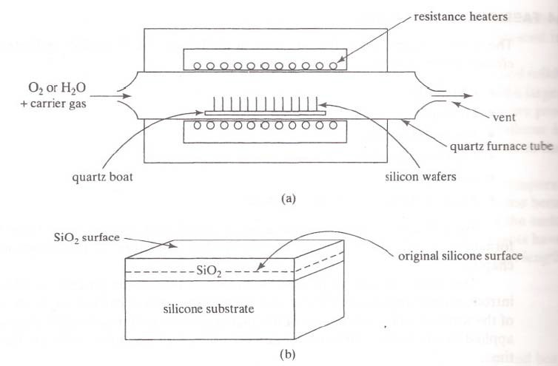
The presence of another material such as silicon nitride (Si₃N₄) on the surface inhibits the growth of oxide in that region. This allows selective or local oxidation of the substrate surface -will be used to isolate devices or conductive layers. A large black-n-white layout of the desired pattern of opening is made and then reduced photographically. This negative (or stencil) of the required dimensions is placed as a mask over the photo resist. By exposing the KPR to UV light through the mask, the photo resist becomes polymerized under the transparent regions of the stencil.
First step in photolithography is to coat the surface with approx 1 μm of photoresist (PR) (a light-sensitive polymer). The PR is then exposed to UV (ultraviolet) radiation through a mask (POSTIVE AND NEGATIVE PR)
Developer layer: The photoresist is developed by flooding it with a liquid developer. Assume a negative PR for this example, so the PR on the sides will be weakened and removed by the developer
The mask is now removed and wafer is developed using chemical (such as trichloroethylene) which dissolves the unexposed portion of the photo resist film. Now the chip is immersed in an etching solution of HCl, which removes the oxide from the areas through which dopants are to be diffused. After etching and diffusion of impurities, the resist mask is removed with a hot H₂SO₄.
Photolithography - Development
The PR is then developed using a chemical developer
Two possibilities:
A negative PR is hardened against the developer by the UV radiation, and hence remains on the surface where UV shone through the mask
A positive PR is the opposite, it is removed where the UV shone through the mask
Assume a negative PR for this example, so the PR on the sides will be weakened and removed by the developer
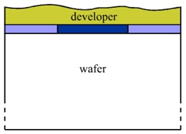
Photolithography
The wafer is baked at 100°C to solidify the resist on the wafer. The reticle is placed on the wafer and aligned by computer control. The reticle is exposed to ultraviolet light with the transparent parts of the reticle passing the light onto the wafer. The photoresist under the opaque regions of the reticle is unaffected. The exposed photoresist is chemically removed by dissolving it in an organic solvent and exposing the silicon dioxide underneath. This is a process very similar to that used in developing photographic film. The exposed silicon dioxide is then etched away using hydrofluoric acid, which dissolves silicon dioxide and not silicon. The regions under the opaque part of the reticle are still covered by the silicon dioxide and the photoresist. The photoresist under the opaque regions of the reticle is stripped using a proper solvent and the silicon dioxide is exposed.
ETCHING
Etching is the selective removal of material from the chip surface
Types are
- In dry etching, ions of a neutral material are accelerated toward the surface and cause ejection of atoms of all materials
- In wet etching, a chemical etchant is used to remove material via a chemical reaction
Three method/process of etching are selectivity, isotropic and anisotropy are
- Selectivity; Etching to remove one material on the surface while leaving another intact. HCl dissolves Sio₂ no silicon
- Isotropic: Etching to proceed laterally as well as downward.
- Anisotropic: Etching to proceed downward only
Diffusion
Most of these diffusion processes occur in two steps: the predeposition and the drive-in diffusion.
In the pre deposition step, a high concentration of dopant atoms are introduced at the silicon surface by a vapor that contains the dopant at a temperature of about 1000°C. In recent years Ion Implantation is used.
Drive in process is used to drive the impurities deeper into the surface without adding anymore impurities
Dopant Diffusion
Dopant can be introduced into the substrate through diffusion. Diffusion is a general physical process which drives particles down a concentration gradient. Diffusion depth is controlled by the time and temperature of the drive-in process
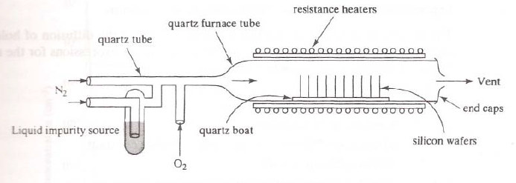
- Ion Implantation: dopant atoms are accelerated toward the substrate surface and enter due to their kinetic energy.
- This is the preferred technique for introduction of dopant atoms since the amount of lateral diffusion is much lower.
Advantages of Ion Implantation
- Doping levels can be precisely controlled since the incident ion beam can be accurately measured as an electric current.
- The depth of the dopant can be easily regulated by control of the incident ion velocity. It is capable of very shallow penetrations.
- Extreme purity of the dopant is guaranteed.
- The doping uniformity across the surface can be accurately controlled.
- Because the ions enter the solid as a directed beam, there is very little spread of the beam, thus the doping area can be clearly defined.
ANNEALING: Implantation is followed by annealing, that is, heating the wafer to a temperature high enough to cause controlled diffusion of the implanted dopant atoms
DEPOSITION
Layers of materials such as metal (and in some cases silicon dioxide) may need to be formed on the surface. General procedure of forming a layer of material on the surface is termed deposition
Two types can be identified, physical and chemical
- In physical deposition, a piece (target) of the material to be deposited is bombarded with ions, ejecting atoms of material which then adhere to the substrate surface
- Chemical deposition uses an ongoing chemical reaction to form the desired material as a precipitate on the substrate surface
- A specialized form of deposition is epitaxy, the formation of a layer of crystalline semiconductor material
PATTERNING; The use of a series of PR deposition, exposure, development and etching to create regions of particular shape is called patterning
Scribing and Cleaving
- Scribing refers to creating a groove along scribe channels which have been left between the rows and columns of individual chips (during mask generation)
- Cleaving is the process of breaking the wafer apart into individual dice
ALUMINIUM METALIZATION
- Metalisation is used to interconnect the various components of the IC. to make these connections, a fourth set of window is opened into a newly formed SiO2 layer at the points where contact is to be made. The interconnections are made using vacuum deposition of a thin even coating of Al over the entire wafer and undesirable Al areas are removed using photoresist technique.
- Sputtering the process of atom ejection from the surface of a solid or liquid following bombardment with ions or atoms. Used to prepare a thin layer of material on an object
TESTING, ASSEMBLY, AND QUALIFICATION
- TESTING, ASSEMBLY, AND QUALIFICATION ●
- After the wafer fabrication process is completed, individual ICs are electrically probed on the wafer to determine which IC chips are functional. The rest are marked and will not be packaged
- After this preliminary functional testing, the wafer is diced into individual circuits or chips by sawing or laser cutting. Functional chips may be encased in plastic or ceramic packages or directly attached to circuit boards. Multiple chips may be put in one package to make multi-chip modules. The electrical connections between the chip and the package are made by automated wire bonding or through solder bumps. In the solder bump process, the metal pads on the IC chip are aligned with the matching pads on the ceramic package. All connections are simultaneously made by melting preformed solder bumps on the IC pads in what is called the flip-chip bonding process. Finally, the package is sealed with a ceramic or metal cover before it undergoes final at-speed testing. As the complexity of ICs increases, testing becomes more and more difficult and expensive. Ease of testing is an important consideration in circuit design.
Plasma- based ion implantation and film deposition system
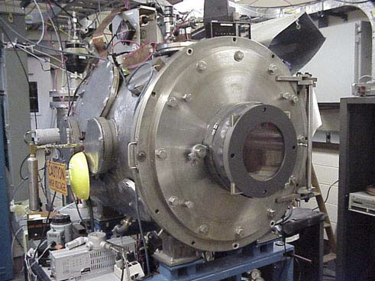
Here is a picture of a state-of-the-art 200 mm Si crystal as they are grown by the thousands for present day (2000) chip manufacture
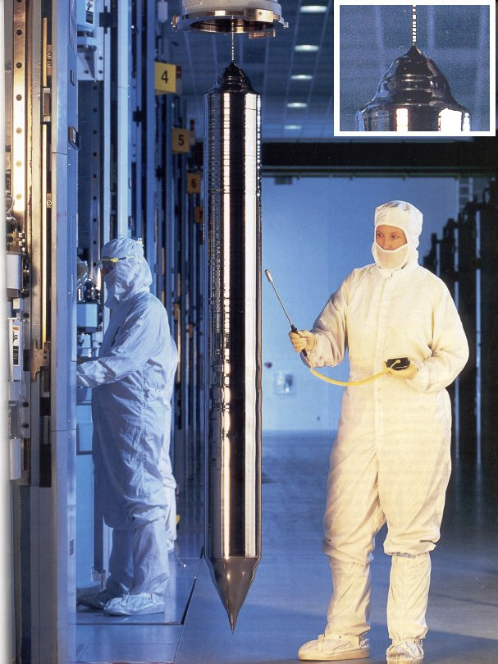
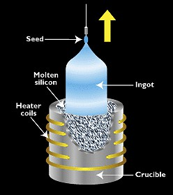0 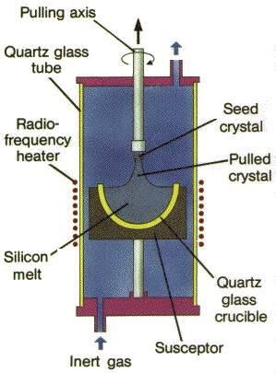
Deep UV Photolithography
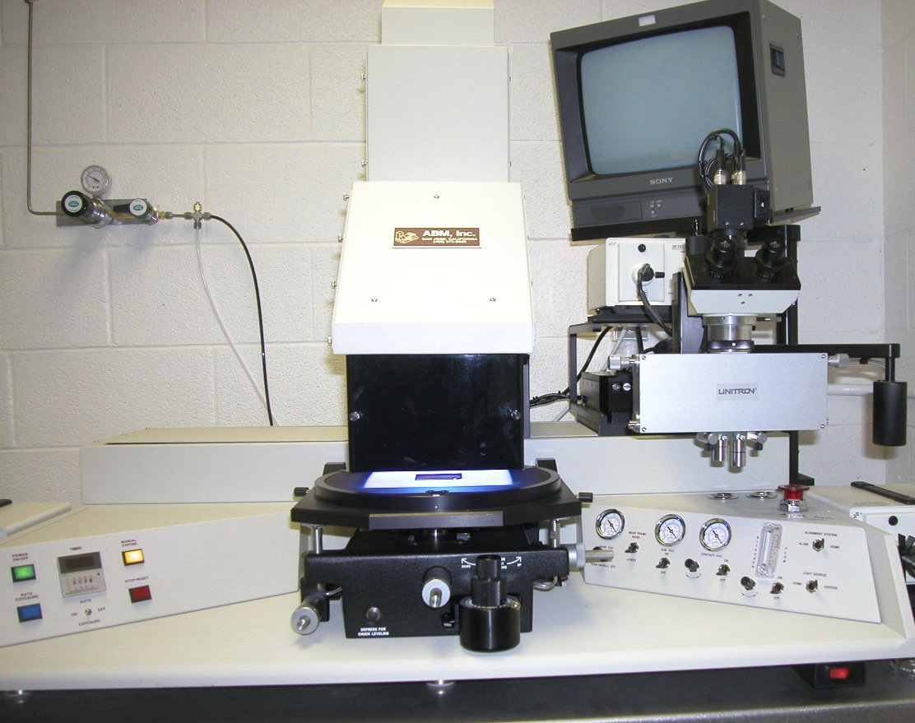
FIBRICATION OF SEMI CONDUCTOR DEVICES
The steps involved in fabrication of a
- Epitaxial growth.
- Create SiO₂
- Open window in SiO₂ and perform boron diffuse to create P-layer. Using photolithography processes
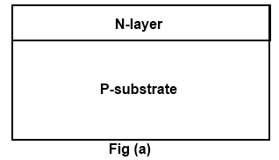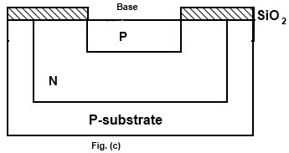

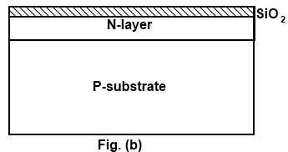

- Oxidation again, open window in new SiO₂ layer perform phosphorus diffusion to create N-layer.
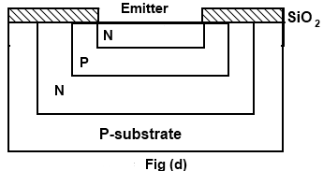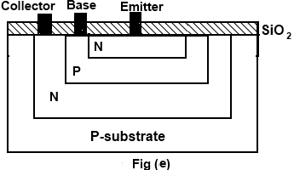
- 5) Oxidize again, open windows for base, emitter and collector contact. Metallization deposit Al, remove all except in contact regions.


- INTRAGATED DIODE AND CAPACITOR
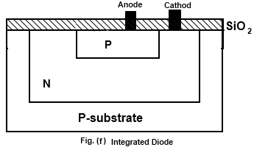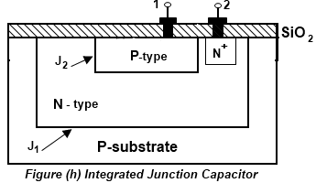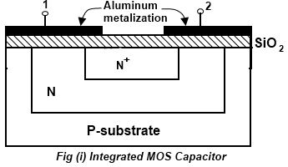



- INTEGRATED RESISTORS
